**Experiment 9**

**Aim:** Shell script to add two matrices

**Software:** Ubuntu

**Procedure:**

* Using command #gedit create a file with .sh extension name it matrix.sh
* Enter the given Shell Script in the file.

matrix1=(1 2 3 4 5 6 7 8 9)

matrix2=(11 12 13 14 15 16 17 18 19)

matrix3=()

rows=3

cols=3

matrix(){

 echo "$1"

 shift

 matrix=("$@")

 for ((i=0;i<rows;i++))

 do

  for ((j=0;j<cols;j++))

  do

  index=$((i*cols+j))

  echo -n " ${matrix[index]} "

  done

  echo

 done

}

matrix "first matrix" "${matrix1[@]}"

matrix "Second matrix" "${matrix2[@]}"

k=0

for ((i=0;i<rows;i++))

 do

  for ((j=0;j<cols;j++))

  do

  index=$((i*cols+j))

  matrix3[k]=$((${matrix1[index]}+${matrix2[index]}))

  k=$((k+1))

  done

  done

matrix "Addition of two matrix" "${matrix3[@]}"

* Use commands #chmod +x filename.sh to give execution rights to the file.
* Then ./filename.sh to launch the file.
* Finally we get addition of two matrics.

**Output:**

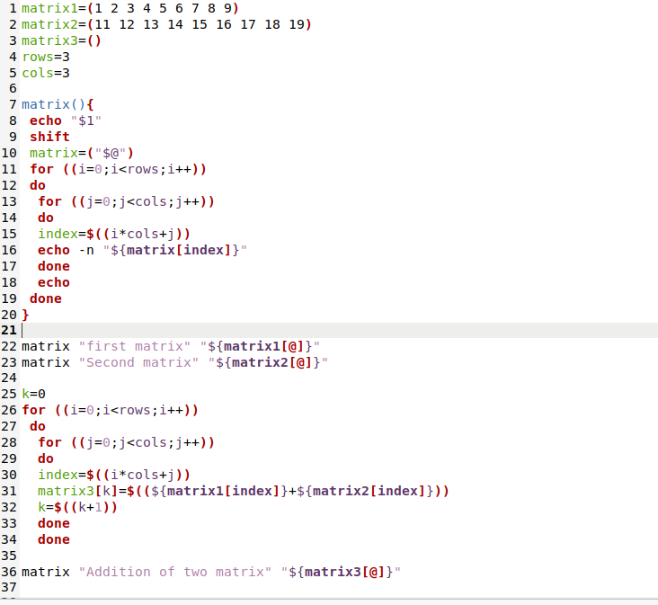

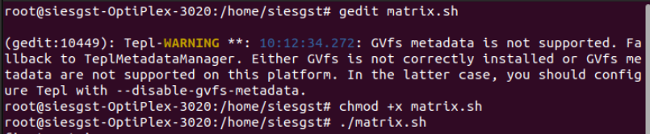

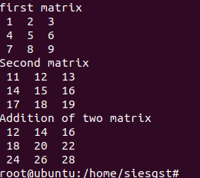

**Conclusion:**

The shell script to add two matrices was performed successfully. Use of function in linux was understood.